

Avaya IX Workplace on Android

Document Control
Document Title: | Avaya IX Workplace Android
Security Classification: | Confidential
Author: | Paul Hrynkiw
Date: | March 2020 Update November 2022 for Avaya v10
Version: | 1.1
Distribution: | IPI Engineering / Customer IT

Head Office / Registered Address  IP Integration Ltd  Integration House  Turnhams Green Business Park  Pincents Lane  Reading  RG31 4UH  T 0118 918 4600  F 0118 918 4601 | Manchester Office  IP Integration Ltd  Holyoake House  Hanover Street  Manchester  M60 0AS  T 0161 241 9600  F 0161 241 9601 | Philippines Office  IP Integration Ltd  Level 26-a Rufino Pacific Tower  6784 Ayala Avenue  Makati City  Metro Manila  Philippines
Registered No. 4210561 VAT No. 792 4208 19






FS 557052 EMS 564375 IS 564376

Overview
The Avaya Workplace application can be used remotely over the internet as your desk extension on Android devices.

security
Avaya Workplace uses Mutual Transport Layer Security (TLS 1.2) to encrypt the VoIP Signalling traffic between the remote worker device and the core of the Avaya solution within Moorcroft premises / Data Centre.
Audio traffic is encrypted using Secure Real Time Protocol using Advanced Encryption Standard (AES) with 256-bit keys.
An Identity certificate is downloaded to the device during setup, which requires a password. The Identity certificate has a 2-year expiry and current certificate remoteworker730d.p12 expires 21/11/2024. IPI Support will update the certificate as part of release management of the solution.
User will log into the application using their Active Directory (AD) Windows password as they would log onto their Desktop/PC.

Process
Below are the steps required to install and configure the Avaya Workplace application used as a Remote Worker via the internet.
# Note – All screen shots are taken from a Samsung Galaxy running Android.

- Install Avaya Workplace application from Android Play Store
- Install Avaya System Manager Root Certificate into Device (only applies to new devices)
- Configure Avaya Workplace Web Address for Auto Configuration
- Enter Client Certificate password

Configuration & Registration now complete

Install Avaya Workplace application
Install Avaya Workplace on Android
Search ‘Avaya Workplace’ in the Play Store
Install the App and Accept the License Agreement

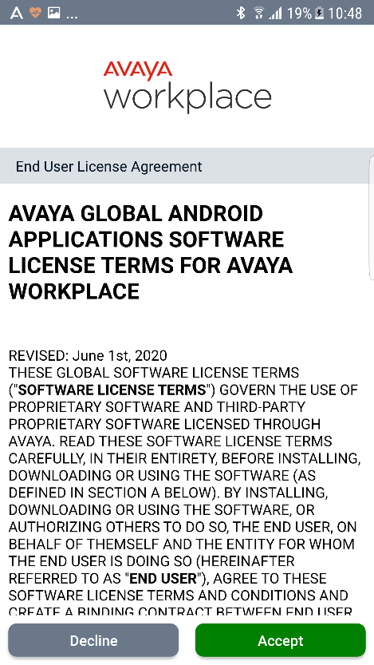

Install Avaya System Manager Root Certificate
# Note – This only applies to new devices that have not previously been registered to the existing Remote Worker setup. If the device has previously been registered this section can be skipped.
From the Android device browse to:
https://mdr-aads.moorgroup.com:8443/SMGRCA.cer
Press ‘Download’ to download the Root Certificate
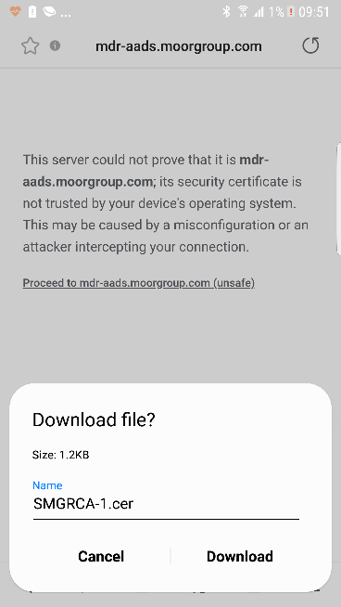
Enter a name for the certificate e.g. ‘Moorcroft Avaya’ and press ‘OK’
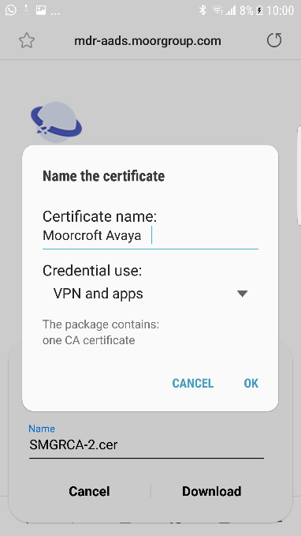
You may be asked to enter your device PIN to install the certificate.
A pop-up saying certificate installed should be seen.

Configure avaya workplace
Launch Avaya Workplace
Press ‘Configure Account’
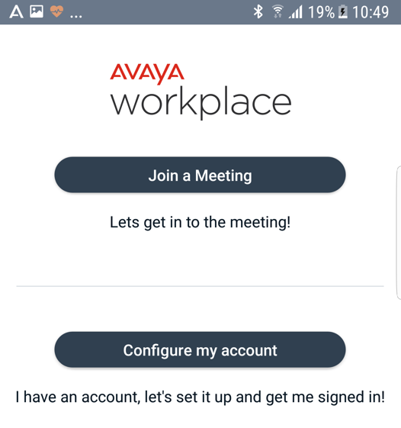

Press the cog icon and select ‘Use a web address’
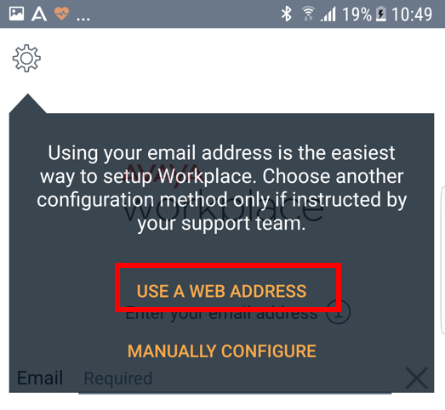

Enter the following Web Address
https://mdr-aads.moorgroup.com:8443/acs/resources/configurations?

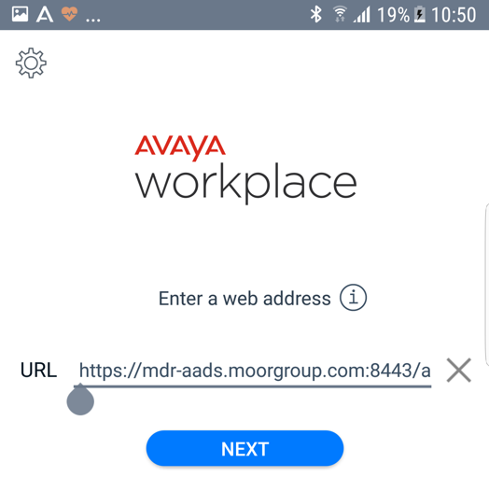

Next you will be asked to enter Workplace Credentials, this is your Moorcroft domain account and Windows password
Example:
Username : joebloggs@moorgroup.com
Password : Windows Domain password
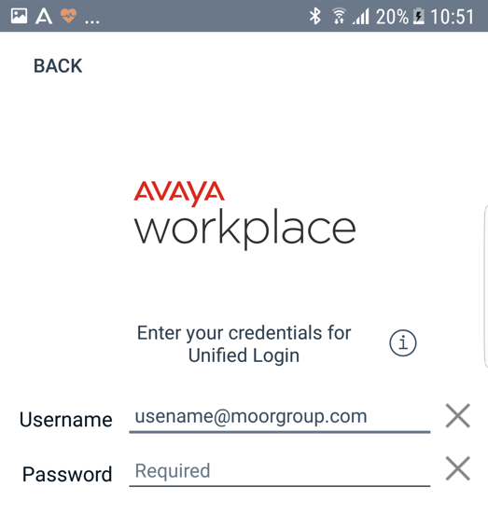

If credentials are successful, you will logged in
Then you will be asked to enter the password for the Client Identity certificate sent by your System Administrator

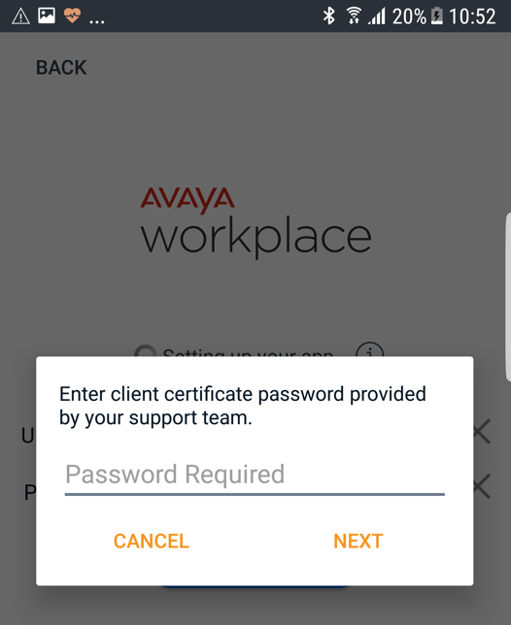
# Note – the Remote Worker application should not be used to make Emergency Calls.
App has logged in successfully, no errors in top bar should be seen

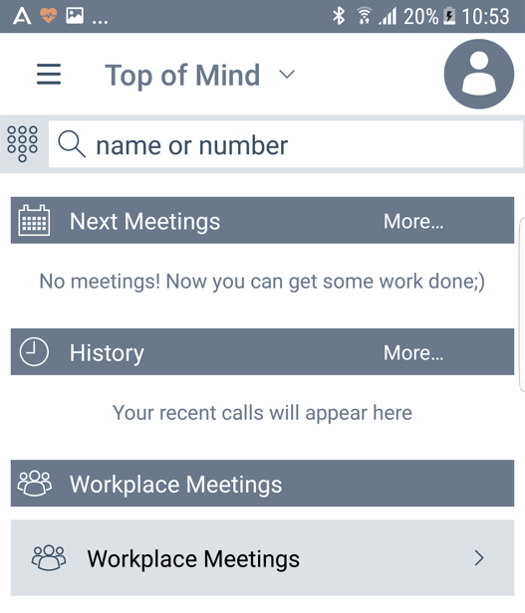
Expiry on Identity Certificate is 21/11/2024
To renew expiring certificate, contact IPI to regenerate the Identity then steps 3 & 4 will need to be completed to update Identity certificate on devices.
IPI will also hold this expiry in Release Management document and reviewed periodically.

